Assignment 4
Introduction
The purpose of the Chatbot is to assess whether the end-user may be experiencing symptoms of depression based on the Diagnostic and Statistical Manual of Mental Disorders (DSM-5) criteria. Additionally, if the end-user is feeling well, the chatbot will inquire about their use of antidepressant medication or other psychology drugs. The end-user, in this context, refers to the individual interacting with the chatbot, likely someone seeking information or assistance regarding their mental health. The end-user will interact with the bot through a conversational interface, typically via text-based messaging. They will input responses to the bot’s prompts and questions, providing information about their symptoms, feelings, and any medication they may be taking. The bot will then analyze these responses to determine whether the end-user may be at risk of depression or if they are currently using medication for mental health purposes. The chatbot is expected to help identify potential symptoms of depression early, allowing individuals to seek appropriate support and treatment promptly by providing a convenient and anonymous platform for assessment to increase accessibility to mental health resources for individuals who may be hesitant to seek help in person. Also, the chatbot can offer tailored recommendations and resources for managing depression symptoms or seeking professional help. Furthermore, through the interaction process, the chatbot can also educate users about depression, its symptoms, and the importance of seeking professional assistance when needed.
Visio was used to build the dialog flow diagram as shown below in Figure 1 to visualize the conversation structure and ensure a seamless and user-friendly interaction experience.
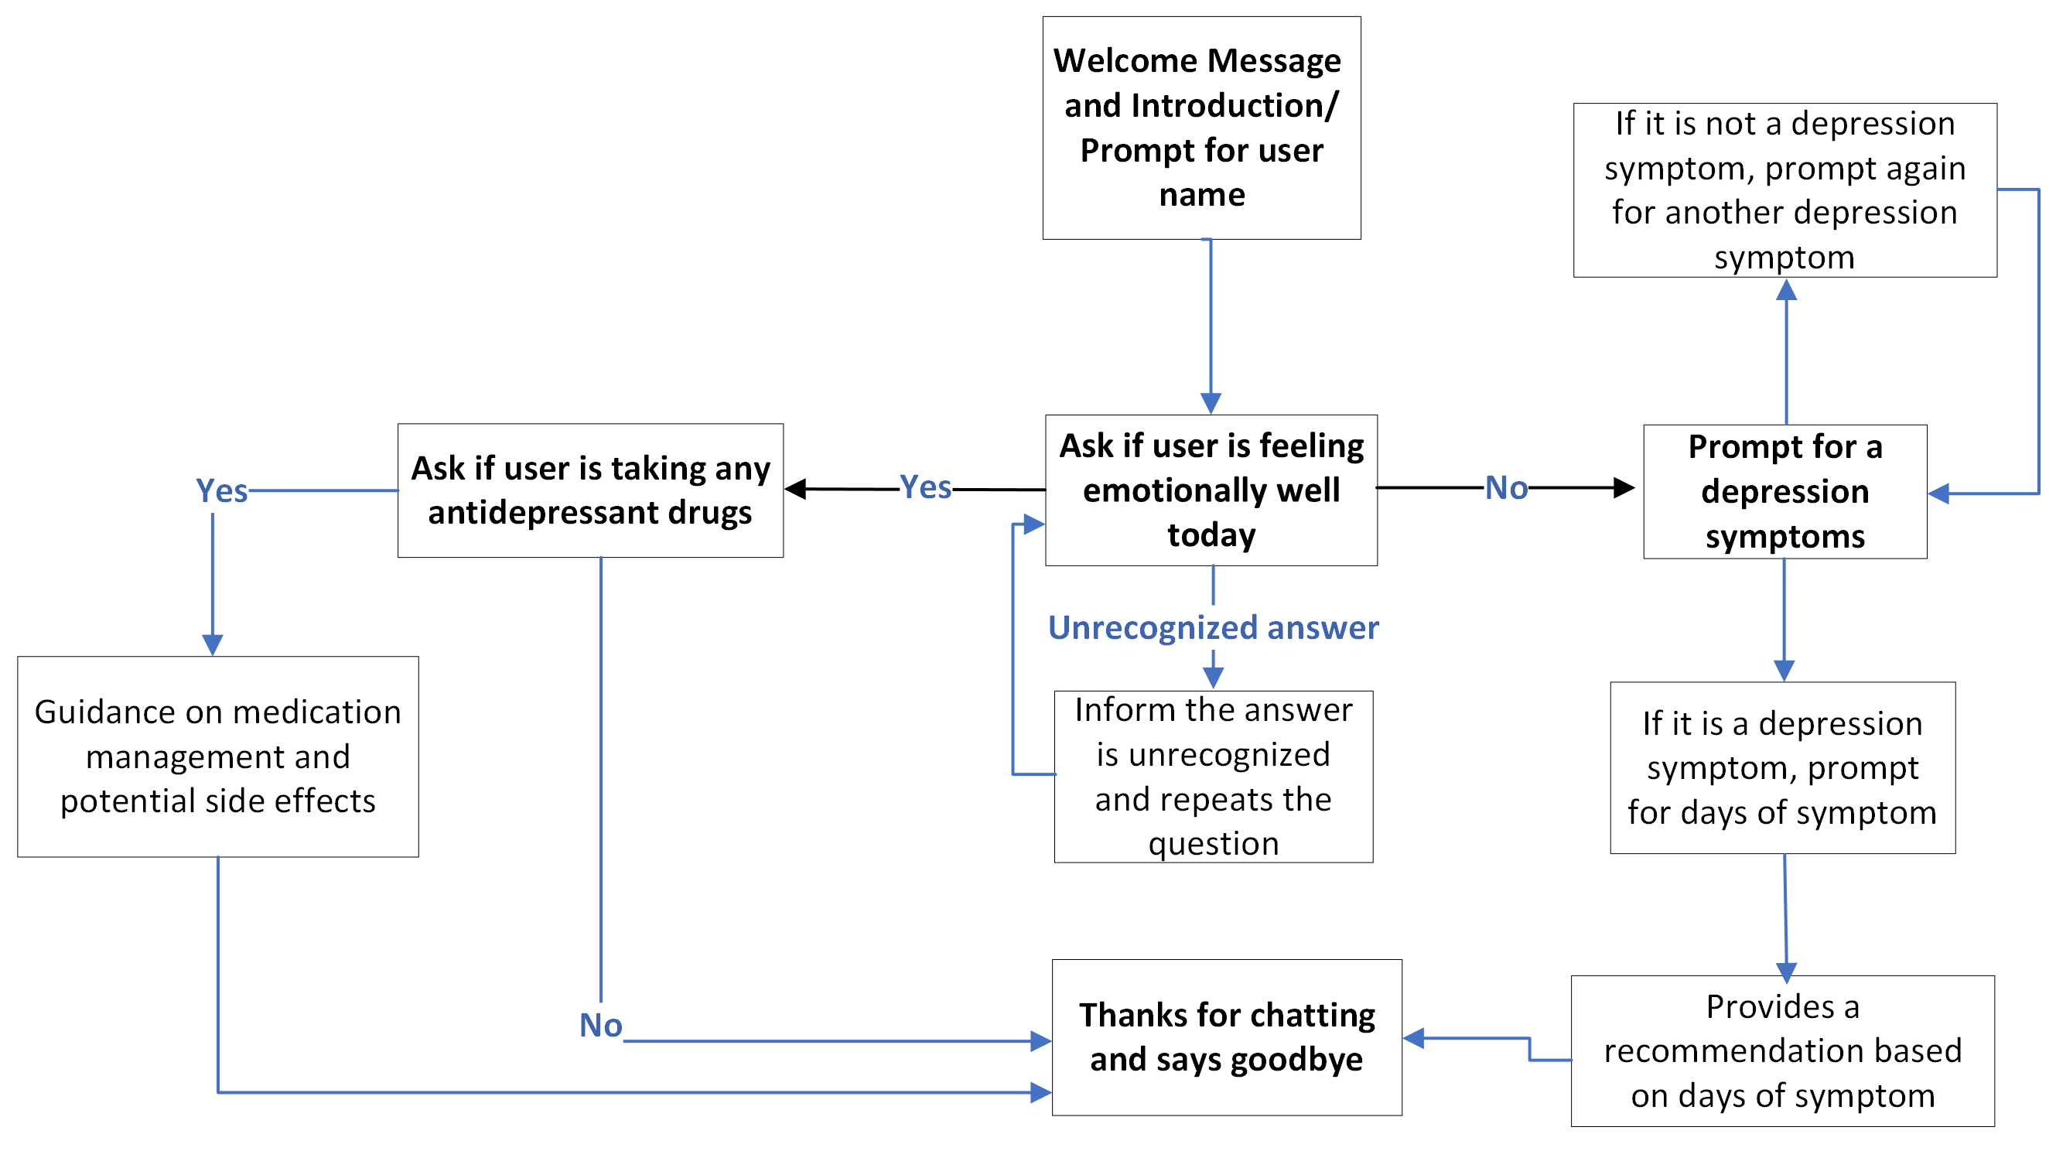
Figure 1. Visio Conversation Dialog Flow Diagram
The first dialog is the “Welcome message and introduction”, which the bot welcomes the user and explains the purpose of the conversation as well as asking for the user’s name. Next, the bot assesses the user’s feelings. Depending on the user’s responses, the bot may ask follow-up questions for clarification. For the next dialog, if the user indicates they are feeling well, the bot inquiries about any antidepressant medication they may be taking. If the user is taking medication, the bot may offer guidance on medication management and potential side effects. Based on the assessment results of symptoms and days of symptoms, the bot provides feedback to the user. If there are indications of depression, the bot recommends seeking professional help and provides resources for support. The dialog then ends with closing and additional support by thanking the user for their participation and offers additional resources such as helplines, online support groups, or mental health website for further assistance.
Dialog Implementation
After visualizing the conversation structure, Watson Assistant was employed to construct the chatbot, incorporating user entities, system entities, intents, context variables, and slots to gather and store user input. Handlers were utilized to quickly address user inquiries while gathering relevant information. Additionally, regular expressions were employed to parse user input, and various response types, including text responses, were implemented. Initially, entities and intents sheets were created, encompassing intents such as emotionally unwell, feeling well, and goodbye, along with entities for depression symptoms and antidepressant drug usage, each supported by at least three examples. These sheets were then uploaded, and dialog nodes were generated. Variations of the Welcome node were established, alongside a child node to store the user's name. A Goodbye node with three variations of image and text responses was also crafted. Subsequently, two nodes, feeling well and not feeling well, were created based on user input. The feeling well node inquired if the user was currently taking antidepressant medication, while the not feeling well node included child nodes for depression symptoms, utilizing slots to gather and store user input. Handlers were employed within the slots to manage invalid inputs, prompting the user to repeat their response if necessary. Users without depression symptoms could exit by typing "Goodbye" as instructed, while those with symptoms would proceed to nodes prompting for the duration of symptoms, utilizing system entities to extract numerical information.
Once all scenarios were configured, testing was conducted using the try it out panel, ensuring smooth functionality across various dialog paths, including scenarios involving emotionally unwell users and those contemplating suicide, with appropriate responses provided and navigation to the Goodbye node upon completion.

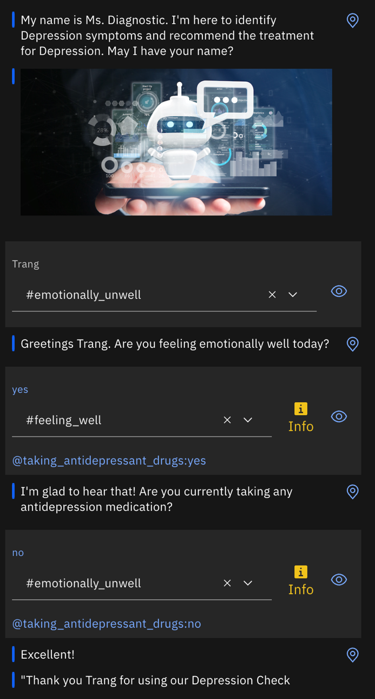
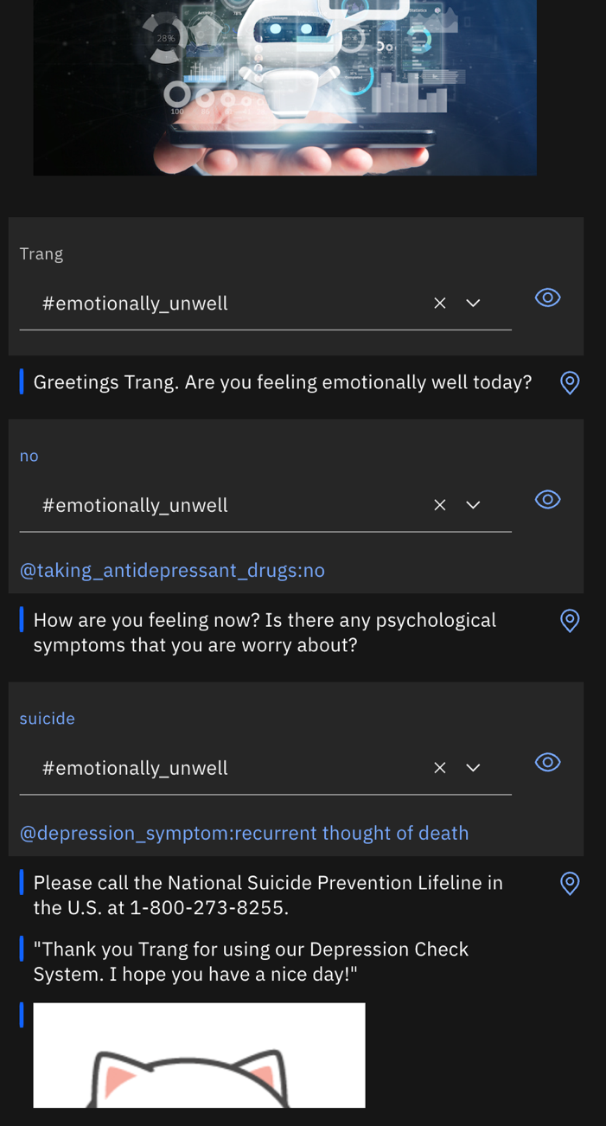

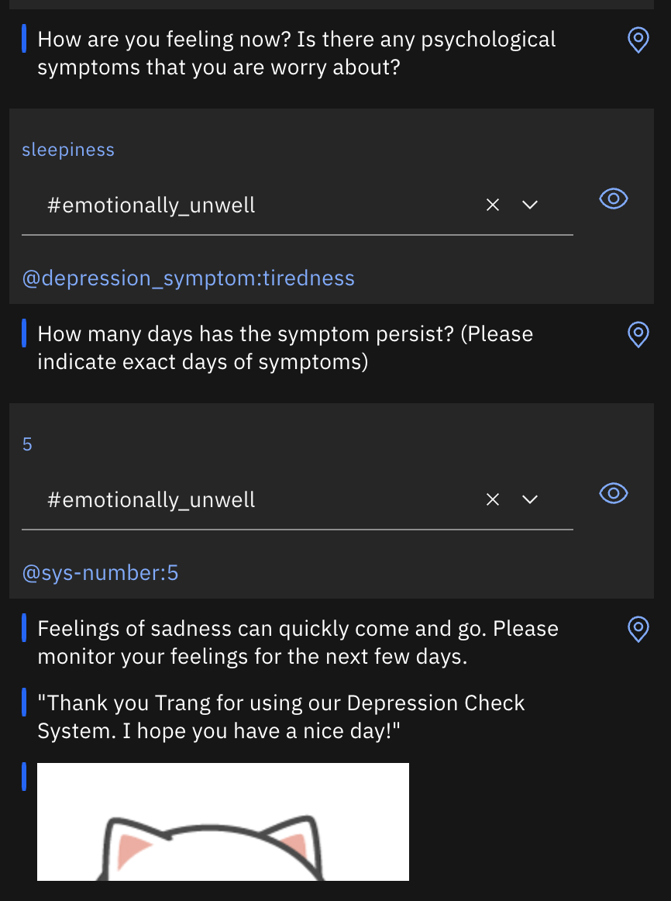
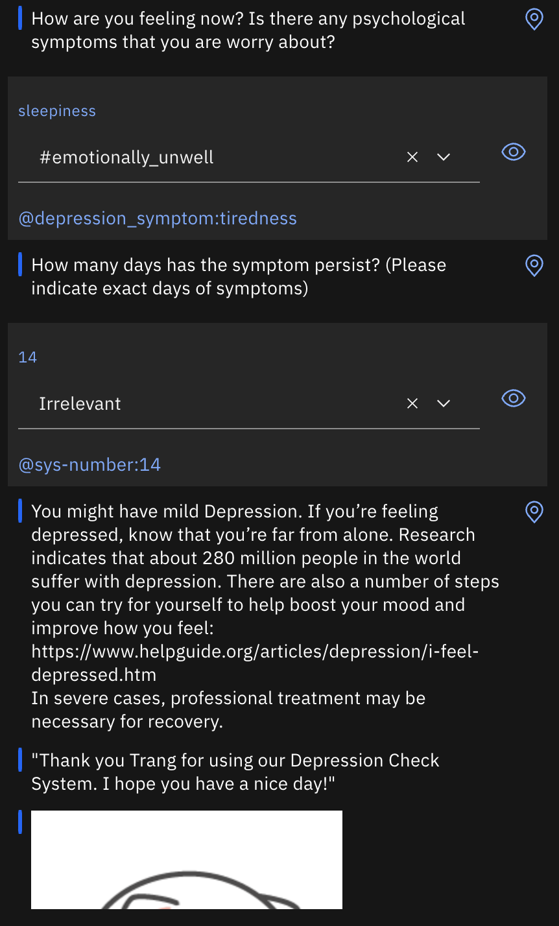

Conversation Data Analysis
After testing with the try it out panel for a few more times and see that there were no issues with the dialog, I created a virtual assistant with the added dialog skill and shared with a few friends: https://web-chat.global.assistant.watson.appdomain.cloud/preview.html?region=au-syd&integrationID=bb64f5da-9d0d-4805-8f30-2228e9dada9b&serviceInstanceID=8bcfd093-45e7-44d7-bd5b-a254b15714d6. I asked each participant to run 3 to 4 conversations and here is the conversation analytics overview tab:
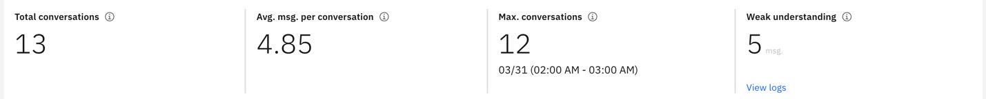
After the first day of sharing, I have total of 13 conversations with average messages per conversation are 4.85 with weak understanding of 5 messages. When checking for the top intents and entities, surprisingly top intent is emotionally unwell while taking antidepressant drug is the top entity being mentioned. The reason might be the user might feel emotionally unwell but it does not associate with depression symptoms in the entities.
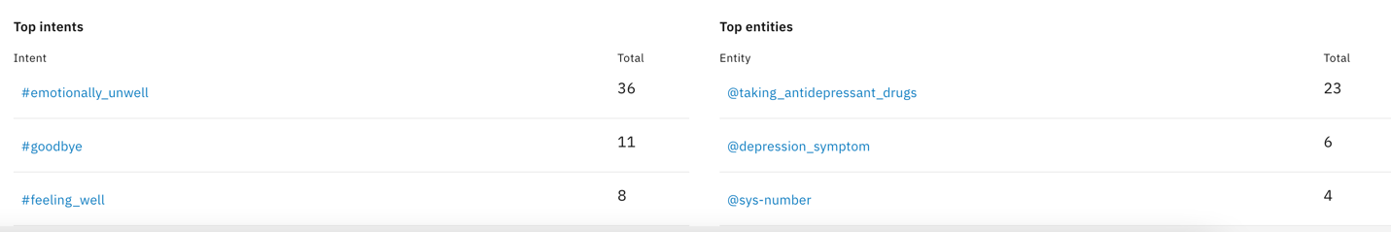
When checking for weak conversation, I realized that weight loss and lose weight were not being trained as depression symptom and marked as irrelevant, thus I trained it as emotionally unwell intent and also as depression symptom entities. Most other irrelevant conversations are the users’ name that the chatbot cannot recognize and can be disregarded.
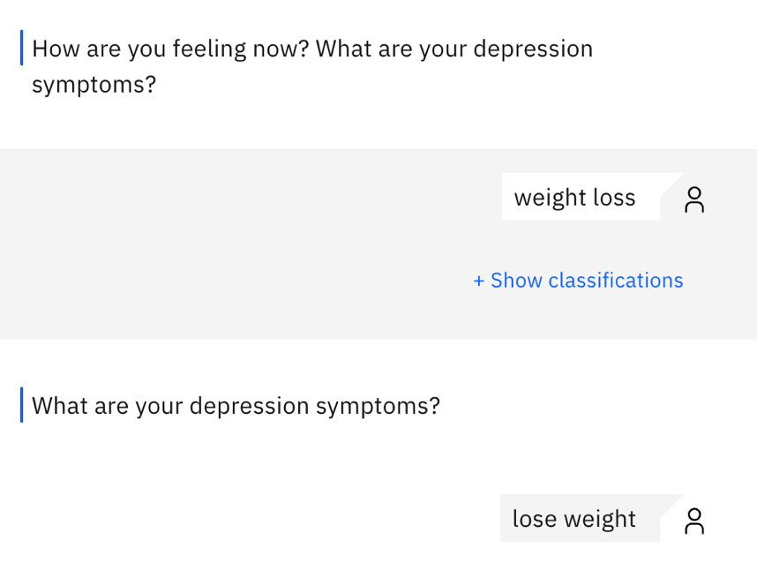
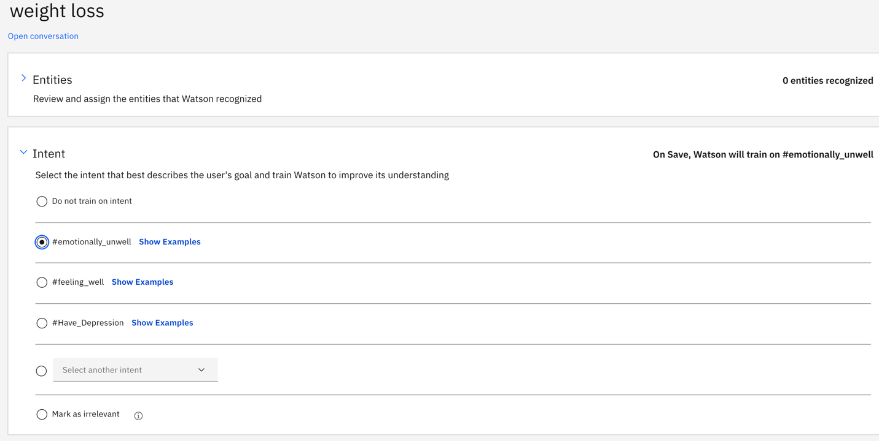
For day 2, I ask each participant to run the same 3-4 conversation again. There are total of 25 conversations for both days with average message per conversation reduces to 4.4 and weak understanding increases to 14. However, when viewing the weak understanding log, all of them are users’ names that the chatbot classify as irrelevant. Furthermore, the top intents and entities remain unchanged. 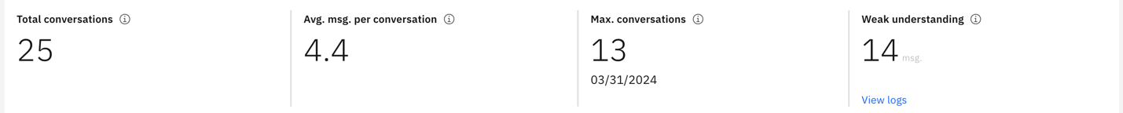
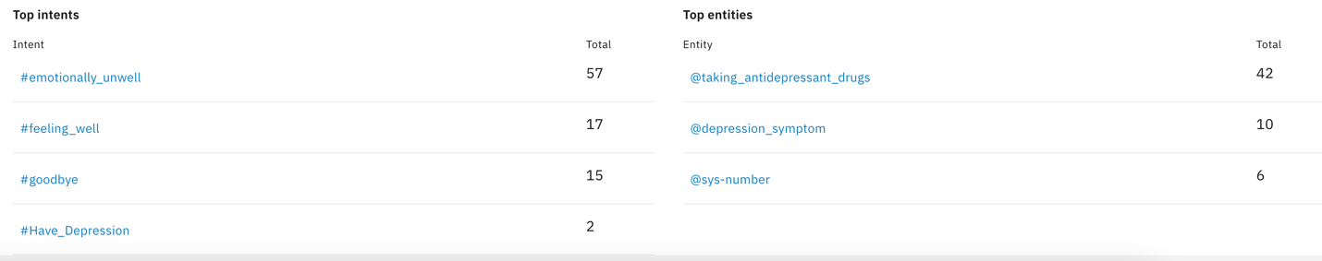
While reviewing the conversations to gauge the chatbot's efficacy in understanding user inputs and delivering relevant responses, it's evident that the chatbot adeptly identifies user intents and offers appropriate responses, maintaining a coherent dialogue flow. However, there are instances where the chatbot misinterprets user intents. For example, when a user expresses a preference for solitude by stating "Like to stay alone," the chatbot incorrectly categorizes it as a goodbye intent rather than recognizing it as a sign of feeling unwell. To address this, I reclassified it under the feeling unwell intent for better accuracy. Additionally, there are challenges with interpreting numerical inputs, such as when a user mentions "2 weeks" instead of "14 days," leading the chatbot to misinterpret the duration of symptoms. To improve accuracy if I were going to run this experiment for a third day, I plan to diversify examples in the depression symptoms entity and explore methods to enhance the chatbot's ability to interpret time-related inputs, such as converting weeks into days for more precise understanding.
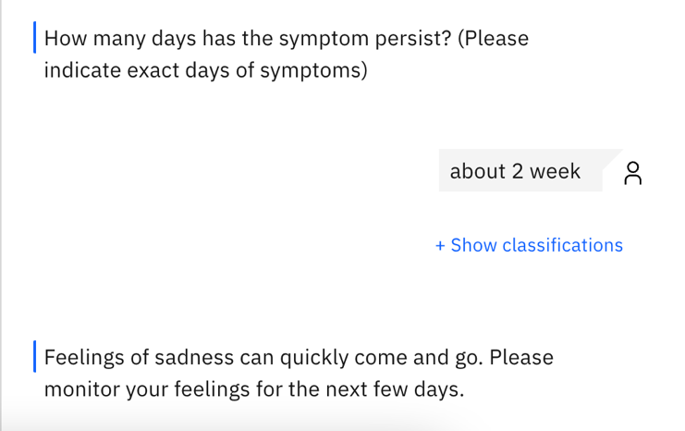
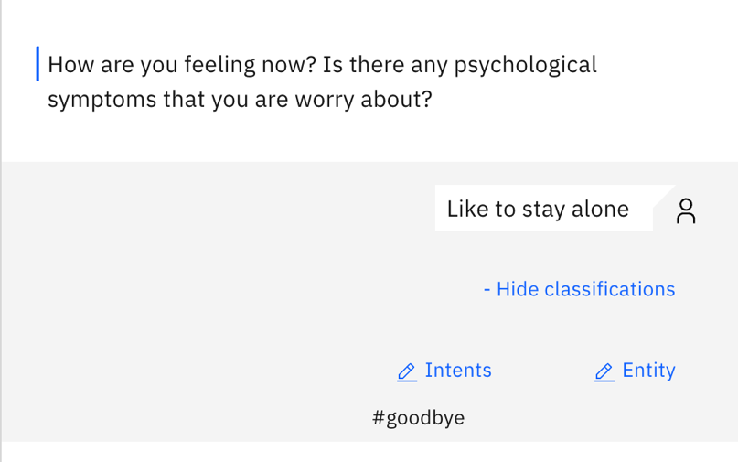

Chatbot Enhancement
Three approaches that I used to personalize the interaction with the chatbot are user profiling, contextual understanding, and behavioral analysis. First, I collect and analyze user data to create personalized profiles for each user and use this information to tailor responses and recommendations based on the users’ interactions. Next, algorithms were implemented so that the chatbot can understand the context and continuity in conversations such as flow of conversation and remembering previous interactions and adjusting the responses accordingly. Lastly, user behavior patterns and preferences were analyzed to provide a more personalized experience.
Response disambiguation refers to the process of clarifying ambiguous or unclear user input to provide accurate response (IBM Cloud, 2023). For example, when user put in irrelevant information that the chatbot could not understand, it would ask the user to clarify the input by saying “Can you paraphrase the sentence?” Another example would be when the user input not feeling emotionally well, the chatbot would ask for the symptoms to clarify if the feeling emotionally unwell is a symptom of depression.
Integration of Natural Language Understanding (NLU) would help analyze and interpret user input more accurately. NLU can extract entities, sentiments, and keywords from the user’s messages, allowing the chatbot to understand user intent and context better (RPA Champion, 2021). Language Translator would help translate text, documents, and websites from one language to another, allowing users with language barriers to engage in the chatbot without having to know the language (IBM Cloud, 2023).
Two approaches to add dynamic content to the chatbot to provide the broader range of responses to users’ questions without hardcoding are integrating the chatbot with a content management system (CMS) integration to dynamically fetch and update responses based on real-time content changes and connect the chatbot to external APIs that provide real-time data and information relevant to user queries (Fitzgerald, 2022). By querying these APIs dynamically, the chatbot can retrieve up-to-date responses without the need for manual updates (Sharma, 2021).
To deploy the chatbot, I would choose a versatile and widely-used messaging platform such as Slack for extensive user bases, built-in features for chatbot integration, and robust developer tools for customization. Additionally, it supports various media format and interactive elements, enhancing the chatbot’s engagement and functionality. To further train the chatbot after deployment, I would gather and analyze the user feedback to identify areas for improvement and fine-tune the chatbot’s responses and behavior accordingly. Moreover, implement machine learning algorithms that enable the chatbot to learn from new interactions and adapt its responses over time. This involves updating the chatbot’s training data and algorithms periodically to incorporate new insights and trends (Leah, 2024).
Conclusion
The implementation of chatbots presents several challenges, including difficulties in natural language understanding, the necessity for personalized responses, and the ongoing need for maintenance and update to keep the chatbot relevant and effective. To address these challenges and build “smart” chatbots, it is essential to invest in advance AI and machine learning technologies, prioritize user-centric design principles, and adopt an interactive development approach that incorporates user feedback and data-drive insights. While chatbots can provide valuable support and assistance, they are unlikely to completely replace human interaction. Live person interaction offers empathy and nuanced understanding that chatbots may struggle to replicate, however, chatbots can complement human interactions by providing efficient, scalable support in certain scenarios. Ultimately, finding the right balance between chatbot and human interaction depends on the specific context and goals of the interaction and is very promising in the near future.

References
Fitzgerald, Anna (Aug 2022). What is a CMS and Why Should You Care? Retrieved from: https://blog.hubspot.com/blog/tabid/6307/bid/7969/what-is-a-cms-and-why-should-you-care.aspx
IBM Cloud (Mar 2023). Controlling the Conversational Flow. Retrieved from: https://cloud.ibm.com/docs/assistant?topic=assistant-dialog-runtime#:~:text=Digressions-,Disambiguation,to%20pick%20the%20right%20one.
IBM Cloud (Aug 2023). Language Translator. Retrieved from: https://cloud.ibm.com/catalog/services/language-translator
Leah (Mar 2024). How to Build an AI Chatbot for Your Website. Retrieved from: https://www.userlike.com/en/blog/chatbot-for-website
RPA Champion (Feb 2021). IBM Watson – Natural Language Understanding. [Video]. Retrieved from: https://www.youtube.com/watch?v=K8zlDNOEHew
Sharma, Anuj (Jan 2021). Creating Dynamic Chatbots with Watson Assistant. Retrieved from: https://medium.com/ibm-data-ai/creating-dynamic-chatbots-with-watson-assistant-5ed825958c8c

